**Supplemental information file for the paper ‘The increase in lifespan inequality in inter-war female cohorts in Denmark?’**

**Authors:** José Manuel Aburto a*, Maarten Wensink a*, James W. Vaupel a,c & Rune Lindahl-Jacobsen a

**Author affiliations:**

a Max-Planck Odense Center on the Biodemography of Aging, Department of Public Health- Epidemiology, Biostatistics and Biodemography, University of Southern Denmark, Odense 5000, Denmark.

c Max Planck Institute for Demographic Research, Rostock 18057, Germany

* These authors contributed equally to the paper

**Keywords:** Demography, life expectancy, lifespan variability, aging, mortality.

**Abstract**

**Background**

**Methods**

**Results**

**Conclusions**

**Table 1. ICD code for the cause of death classification.**

|  |  |  |  |  |
| --- | --- | --- | --- | --- |
| **Cause of Death** | **ICD-7** | **ICD-8** | **ICD-9 (Sweden, Norway)** | **ICD-10** |
| Infectious, non-respiratory | A001-A043 | A001-A044 | B01-B07, B184-B185 | A00-B89, B99 |
| Cancer, amenable to smoking | A044-A050, A052, 157, 180-181 | A045-A051, A055, 157, 188-189 | B08, B090-B094, B096, B100-B101, 180, 188-189 | C00-C21, C25, C30-C34, C53, C64-C68 |
| Cancer, not amenable to smoking | A051, A053-A056, A058-A059, 155-156, 158-160, 164-165, 175-176, 178-179, 192-195, 198-199 | A052-A054, A056-A057, A059-A60, 155-156, 158-160, 163, 171, 183-184, 186-187, 190-199 | B095, B099, B109, B11, B13-B14, 179, 181-187 | C22-C24, C26, C37-C39, C40-C41, C43-C52, C54-C58, C60-C63, C69-C97 |
| Diabetes mellitus | A063 | A064 | B181 | E10-E14 |
| Cardiovascular | A070, A079-A086 | A080-A088 | B25-B30 | I00-I99 |
| Respiratory, infectious | A087-A092, A095 | A089-A092, A095 | B310-B312, B320-B322 | J00-J06, J09-J18, J20-J22, J34.0, J36, J39.0, J39.1, J85, J86 |
| Respiratory, non-infectious | A093, A094, A096, A097 | A093, A094, A096 | B313-B315, B319, B323-B327, B329 | J30-J33, J34.1-J34.3, J34.8, J35, J37, J38, J39.2, J39.3, J39.8, J39.9, J40-J47, J60-J70, J80-J82, J840-J841, J848-J849, J90-J99 |
| External | A138-A150 | A138-A150 | B47-B56 | S00-T89, V01-Y84 |
| Other | A060-A062, A064-A069, A071-A078, A098-A137 | A061-A063, A065-A079, A097-A137 | B15-B17, B180, B182-B183, B189, B19-B23, B33-B46 | D00-D48, D50-D89, E00-E07, E15-E16, E20-E35, E40-E46, E50-E68, E70-E90, F00-F99, G00-G99, H00-H59, H60-H95, K00-K93, L00-L99, M00-M99, N00-N99, O00-O99, P00-P96, Q00-Q99, R00-R99 |

**Details on the classification**

Primary malignancies that are amenable to smoking are found predominantly in the respiratory, digestive and genitourinary tracts, in line with the rule that where smoke or its products pass, cancer arises. Primary malignancies in the gastrointestinal tract from mouth to anus were classified as amenable to smoking, as was the respiratory tract. In addition, it has been proven that smoking causes cancer of the uterine cervix, the ovaries (mucinous carcinoma), the bladder, the kidney (pelvis and body) and the ureter. For mucinous carcinoma of the ovaries, detail could not be reconstructed across ICD versions (see below). Malignancies in the urinary tract were classified as being amenable to smoking.

The resolution of the ICD classification has grown substantially over the years. As we analyzed deaths from 1960 through 2014, we used ICD-7 through ICD-10. The specifically identified categories “cancer amenable to smoking” and “respiratory infectious”, are based on the smallest common denominator: only if a specific disease could be separately identified across ICD versions did we include it in these groups. For instance, myeloid leukemia has been associated with smoking, but ICD-7 and -8 contain only a category ‘leukemia’, without subclassification. Hence, for reasons of consistency across classifications, myeloid leukemia is considered as not amenable to smoking throughout. Also, ICD-7 and ICD-8 have an overall rest group for malignant neoplasms, while ICD-9 and ICD-10 have also a rest group for each tract, if known. Because ICD-7 and ICD-8 do not have these detailed rest groups, rest groups were classified as not amenable to smoking for all ICDs.

**Brief description of the indicator**

In lifetable notation, it is:

$$CV=\frac{\sqrt{\int_{a}^{ω}{{(x-e_{a})}^{2}f\left(x\right)\text{d}x}}}{\int_{a}^{ω}{l\left(x\right)\text{d}x}}=\frac{σ}{e_{a}}. (1)$$

Where $f\left(x\right),e_{0}$ and $ω$ denote the age at death density function, life expectancy at age $a$, and the open-aged interval (110+ in our case), respectively.

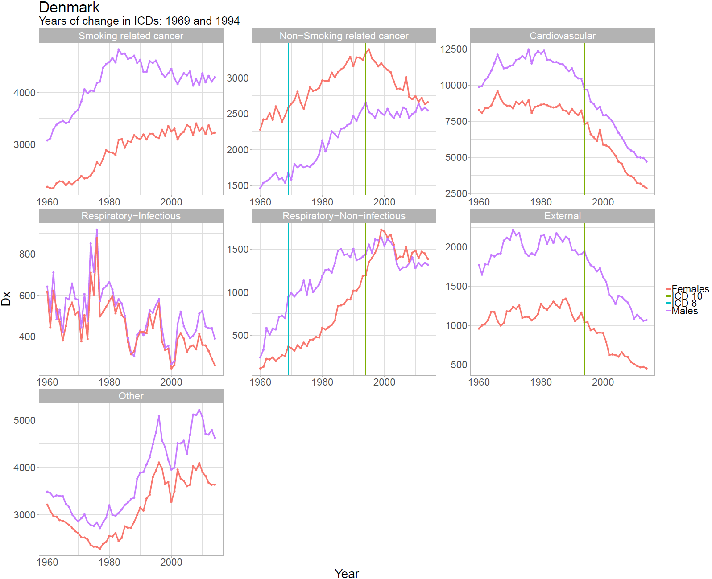Sensitivity analysis of cause of death differences in ICD coding

